

Draw It or Lose It

# **CS 230 Project Software Design Template**

Version 3.0

## Table of Contents

**CS 230 Project Software Design Template**1

**Table of Contents**2

**Document Revision History**2

**Executive Summary**3

**Design Constraints**3

**System Architecture View**3

**Domain Model**3

**Evaluation**4

**Recommendations**8

## Document Revision History

|  |  |  |  |
| --- | --- | --- | --- |
| Version | Date | Author | Comments |
| 1.0 | <05/17/21> | Nathan Chuluda | First iteration of the Software Design Template |
| 2.0 | <06/01/21> | Nathan Chuluda | Expanded the Evaluation Section |
| 3.0 | <06/11/21> | Nathan Chuluda | Expanded the Recommendations Section |

**Instructions**

Fill in all bracketed information on page one (the cover page), in the Document Revision History table, and below each header. Under each header, remove the bracketed prompt and write your own paragraph response covering the indicated information.

## Executive Summary

Draw It or Lose It is currently available as an app only to Android users. To make the game available to more players, a web based version of the game will be developed. The web application will be platform independent and will not require being downloaded to the device as an app. Instead, it will be transferred to players each time it is accessed in the web browser. Increased server bandwidth will be required to provide the web application each time a player accesses the game.

## Design Constraints

Care must be taken to ensure the game performs well on all devices. A responsive approach to web development will be utilized so that the game is displayed properly on desktop computers, laptops, tablets, and cell phones, regardless of screen size.

Attention to the file size of the completed game must be taken to ensure reasonable loading times for the players and limit server costs induced to The Gaming Room for bandwidth.

## System Architecture View

Please note: There is nothing required here for these projects, but this section serves as a reminder that describing the system and subsystem architecture present in the application, including physical components or tiers, may be required for other projects. A logical topology of the communication and storage aspects is also necessary to understand the overall architecture and should be provided.

## Domain Model

<Describe the UML class diagram provided below. Explain how the classes relate to each other. Identify any object-oriented programming principles that are demonstrated in the diagram and how they are used to fulfill the software requirements efficiently.>

The Singleton Pattern is used to ensure that only one instance of the game can be in memory at any time using the Entity class. The Game, Team, and Player classes all include unique IDs so that more than one instance cannot be created with the same name. The Game class contains a list of Teams. The Team class contains a list of Players.

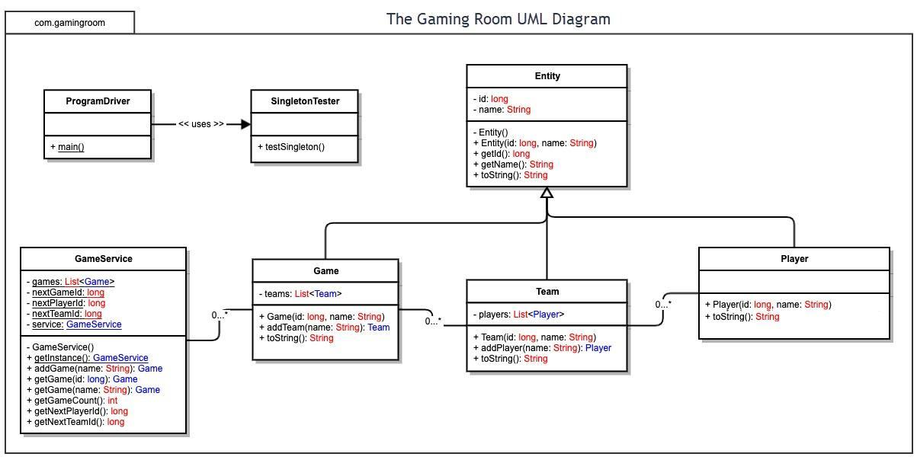

## Evaluation

Using your experience to evaluate the characteristics, advantages, and weaknesses of each operating platform (Linux, Mac, and Windows) as well as mobile devices, consider the requirements outlined below and articulate your findings for each. As you complete the table, keep in mind your client’s requirements and look at the situation holistically, as it all has to work together.

In each cell, remove the bracketed prompt and write your own paragraph response covering the indicated information.

|  |  |  |  |  |
| --- | --- | --- | --- | --- |
| **Development Requirements** | **Mac** | **Linux** | **Windows** | **Mobile Devices** |
| **Server Side** | Mac OSX Server is less common than Windows and Linux for hosting websites. Although it would be possible, it would not be preferable to choose Mac OSX Server to host this game. | Linux is the most popular choice for web hosting. It is open source, secure, fast, and reliable. It is generally cheaper than Windows based hosting. There are Linux distributions that are available free, such as Debian and Ubuntu. Certain other distributions, including Red Hat and SUSE, require a licensing fee. Linux licensing fees are usually considerably less than for Windows. | A popular choice for web hosting servers. Certain Microsoft technologies only work with Windows servers, such as MSSQL and ASP.NET. The Draw It or Leave It web application will not require use of these Microsoft specific technologies. Windows is considered the expensive option, requiring costly licencing for use. | Mobile devices are not appropriate for hosting the web application version of Draw It or Leave It. |
| **Client Side** | Safari is the default web browser for Mac OSX. Other browsers such as Google Chrome and Mozilla Firefox are available to use. In general, web based applications are not dependent on client side platforms. When accessed on a desktop or laptop computer, resolution of the display should be comparable regardless of which operating platform the player is using. Responsive design can be used to shift components of the game depending on the current width of the browser window and pixels available for display output. | Google Chrome and Mozilla Firefox are available for use on Linux systems. As long as responsive web design practices are used, the game will be displayed well regardless of the width in pixels available to the web browser. | Microsoft Edge is the default web browser for Microsoft Windows. Other browsers such as Google Chrome and Mozilla Firefox are available for use. As long as responsive web design practices are used, the game will be displayed well regardless of the width in pixels available to the web browser. | Mobile Devices are most commonly either Apple iOS or Android. Safari is the default browser for iOS devices and versions of Google Chrome are the default web browser for Android devices. Google Chrome and Mozilla Firefox are available for both mobile operating systems. Responsive web design practices can ensure that the game is formatted properly for the smaller screen resolution of mobile devices. |
| **Development Tools** | The web app version of Draw It or Leave It will be developed with React, a javascript library. It is platform independent and will function well across all systems. React is maintained by Facebook and is available for commercial use for free under the MIT license. NodeJS is a javascript runtime environment for handling the back end of the game. It is available for free use under the MIT license. VSCode is a popular freeware IDE made by Microsoft that may be used by the development team. It is available for use on MacOSX, Windows and Linux systems. Should the game become more complex, Visual Studio IDE may  be a better  choice. The Professional and Enterprise  licenses for Visual Studio require monthly subscription licenses for use. | The web app version of Draw It or Leave It will be developed with React, a javascript library. It is platform independent and will function well across all systems. React is maintained by Facebook and is available for commercial use for free under the MIT license. NodeJS is a javascript runtime environment for handling the back end of the game. It is available for free use under the MIT license. VSCode is a popular freeware IDE made by Microsoft that may be used by the development team. It is available for use on MacOSX, Windows and Linux systems. Should the game become more complex, Visual Studio IDE may  be a better  choice. The Professional and Enterprise  licenses for Visual Studio require monthly subscription licenses for use. | The web app version of Draw It or Leave It will be developed with React, a javascript library. It is platform independent and will function well across all systems. React is maintained by Facebook and is available for commercial use for free under the MIT license. NodeJS is a javascript runtime environment for handling the back end of the game. It is available for free use under the MIT license. VSCode is a popular freeware IDE made by Microsoft that may be used by the development team. It is available for use on MacOSX, Windows and Linux systems. Should the game become more complex, Visual Studio IDE may  be a better  choice. The Professional and Enterprise  licenses for Visual Studio require monthly subscription licenses for use. | The web app version of Draw It or Leave It will be developed with React, a javascript library. It is platform independent and will function well across all systems, including mobile devices. Responsive design can be used to ensure the game displays properly across different screen resolution sizes. It may be beneficial to include mobile development specialists on the team who are familiar with user interface design for smaller displays and touch screen interactivity. |

## Recommendations

Analyze the characteristics of and techniques specific to various systems architectures and make a recommendation to The Gaming Room. Specifically, address the following:

1. **Operating Platform**: It is recommended to develop the Draw It or Leave It web app with React, a javascript library. Javascript is platform independent and will work across many modern web browsers such as Google Chrome or Mozilla Firefox on Mac OSX, Linux, Windows, iOS and Android devices. It will utilize Node.js, a Javascript runtime environment, which can be used on Windows, Linux or OSX servers.
2. **Operating Systems Architectures**: Several web browsers could be used to access the game. The operating system of a user would not interfere with delivery of the web application. A cloud service should be used to act as the remote server to host the game.
3. **Storage Management**: MongoDB can be used as a database to store user accounts, gameplay history, high scores, etc. MongoDB is available for use with Mac, Linux, and Windows servers so it permits flexibility when choosing a web hosting server. Data is formatted in JavaScript Object Notation, or JSON. By using a cloud service, the amount of available storage does not need to be planned and decided upon before the game is launched.
4. **Memory Management**: Javascript includes a form of automatic memory management called garbage collection. Node.js is a good choice for a server environment as it handles large amounts of concurrent connections over a single thread. This is an important feature and will help effectively use the memory that is available. Attention should be given to the software code for possible memory leaks during testing.
5. **Distributed Systems and Networks**: Game code will be hosted on cloud based web servers and accessed through web browsers on various devices. Any data that must be saved when the user closes their browser window will be stored in a server database to be retrieved by the user at a later time.
6. **Security**: Sensitive user data such as login and password can be hashed, then encrypted to ensure accounts remain secure. Login tokens can be stored as cookies to keep a user logged in on that unique device for a set period of time. As this web based application will allow users worldwide to register and play, it is important to adhere to the varying guidelines for handling personal information of the players. An example of these are the General Data Protection Regulations (GDPR) that protect citizens of the European Union.